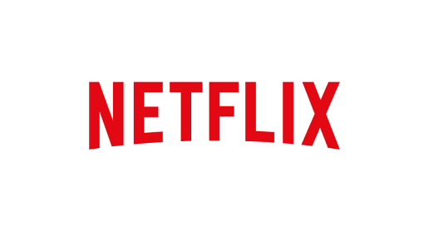

Strategic Analysis Plan Outline
Executive Summary

1. Case Statement

Netflix is “the world’s leading internet subscription service for enjoying movies and TV programs.” It has more than 30 million streaming members in the United States, Canada, Latin America, the United Kingdom, Ireland and the Nordics. It serves customers in nearly 40 countries. The world headquarters of Netflix is located in Los Gatos, California.

Technology is continuing to advance and more competitors are continuing to enter the market. Netflix is the industry leader in this competitive market.

2. Mission and Vision Statement

Mission

“Our core strategy is to grow our streaming subscription business domestically and globally. We are continuously improving the customer experience, with a focus on expanding our streaming content, enhancing our user interface and extending our streaming service to even more Internet-connected devices, while staying within the parameters of our consolidated net income and operating segment contribution profit targets.”

Vision

- Become the best global entertainment distribution service
- Licensing entertainment content around the world
- Creating markets that are accessible to filmmakers
- Helping content creators around the world to find a global audience.

Reed Hastings – Co-founder and CEO of Netflix

Promise

“We promise our customers stellar service, our suppliers a valuable partner, our investors the prospects of sustained profitable growth, and our employees the allure of huge impact.”

3. Internal Analysis
Strengths
    - User Platforms and interface
    - Customer service
    - Brand Recognition
Weaknesses
    - Regulations
    - Cost of original programming
    - Stock value vs. Cost

4. External Analysis
Opportunities
    - Original Programming
    - Subscription deals
    - Increasing streaming
Threats
    - Illegal video streaming
    - Censorship
    - Competition

5. Strategic formation
    - Pricing strategies
    - Marketing Strategies
    - Financial Strategies

6. Recommendations and Implementations
    - Pricing and subscriptions
    - Distribution and expansion
    - Expanding Streaming opportunities

