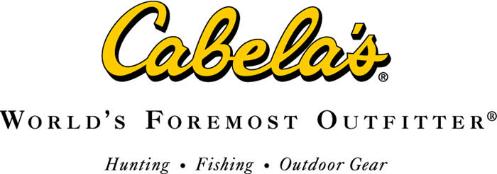
Cabela’s Strategic Plan
NMHU MGMT 489
Melanie Wood

Introduction
Executive Summary
Company history. The Cabela’s story began in 1961, when Dick Cabela placed an ad in a local Wyoming newspaper, selling fishing flies. After only one response, Dick changed his strategy and the orders started to roll in. Cabela’s was initially run by Dick and his wife Mary from their kitchen table in Chappell, Nebraska. Orders were sent out along with a small catalog of outdoor items that the Cabela’s were selling. In 1962, Dick’s younger brother Jim joined his brother and sister in law in the business. After several years, the operation was forced to move into a handful of larger different locations, eventually with headquarters being established in Sidney, Nebraska in 1969. (Hauser, 2016) The first floor housed the very first retail location, while a portion of the second floor was used as an archery range. (Cabela's Inc., 2006) In the 70s and 80s, the company was producing 100 different catalogs, began accepting credit card payments, and implemented a telemarketing department. (Hauser, 2016) In 1998 Cabela’s took their business to the world-wide web. As more stores were opening throughout the United States, Cabela’s chartered the World’s Foremost Bank, who handles the support for the Cabela’s branded credit card. In 2004, the company went public on the New York Stock Exchange. (Company Profile Cabela's Incorporated, 2016)
Core values. The founders of Cabela’s believed that the customer is number one. This is exemplified the core values that help create and nurture the culture at Cabela’s. Superior customer service is given to each and every customer, because “the customer is our reason for being” (Core Values, n.d.). In recognition of customer importance, they are committed to delivering quality products and services. From the top management to the front-line crew, from the suppliers to their customers, Cabela’s believes in treating everyone with integrity and honesty. They strongly believe in respect for individuals and this is evidenced by their recognition and acceptance of diversity within the team. Cabela’s believes their customers deserve excellence in performance. This is achieved by “providing a creative atmosphere in which employees are encouraged to be innovative and far thinking, while providing the expertise to meet the needs of our customers.” (Core Values, n.d.)
Products. Cabela’s operates a multi-channel outdoor business with over 200,000 products ranging from hunting, fishing, and camping, to outdoor apparel and footwear, to home furnishings with a woodsy feel. They offer everything a hunter needs from a blind and decoys to knives and tools. The omni-channel retailer even carries food processing and kitchen equipment to turn your game into readily usable meats. For the firearm enthusiasts, they carry ammunition, optics, targets, and supplies necessary for reloading. For the fishing enthusiast, there is a selection of fishing rods, reels, hand tied flies, and other fishing accessories. The apparel offered includes tee shirts, flannel shirts, jeans, shorts, jackets, and more. Apparel and footwear name brands such as The North Face, Columbia, Under Armour, Wrangler, Keen, Danner and even Carharrt are carried. (Cabela's , n.d.) In addition to these big-name brands, Cabela’s also carries their own private label, Cabela’s brand. They are very proud of the quality of their private label. They are able to offer it at lower prices, but not lower quality.

Financial data.
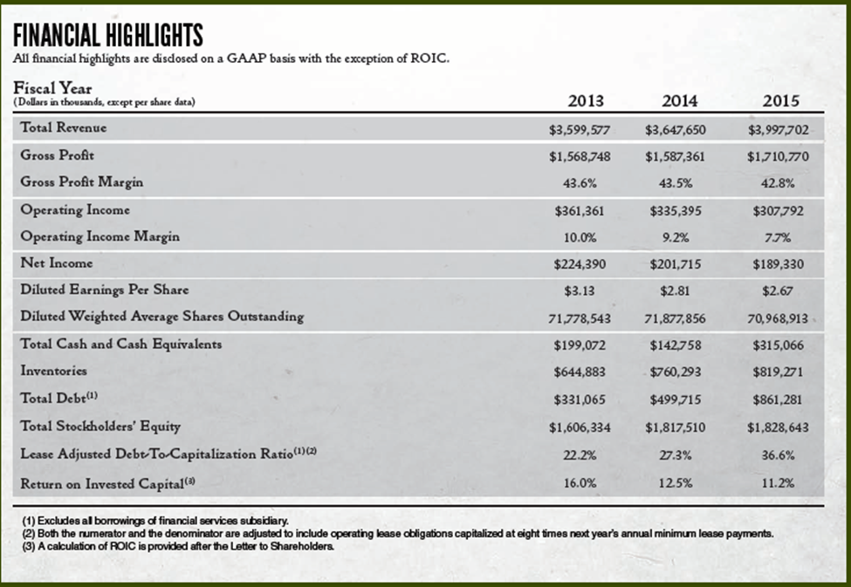
As of April 7, 2017, their stock is trading at $52.96 per share. The total revenue was $3.6 billion in 2014 and increased to $3.9 billion in 2015. Gross profit margin for the same years decreased from 43.5% to 42.8%. Net income also saw a decrease from $201.7 million in 2014 to $189.3 million in 2015. For the fiscal year of 2016, net income saw a further decrease to $146.9 million. Diluted EPS was $2.81 in 2014, $2.67 in 2015, and decreased further to $2.13 in 2016. (Cabela's 2015 Annual Report, 2015)

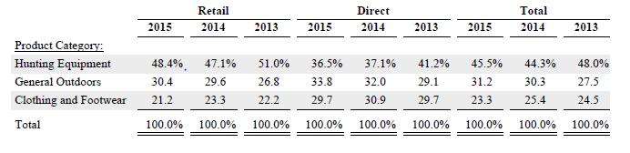
This table provides a breakdown of merchandise revenue contributed by major product categories. From 2014 to 2015 both hunting equipment and general outdoors both raised their total respective percentages while the clothing and footwear percentage declined. (Cabela's 2015 Annual Report, 2015)
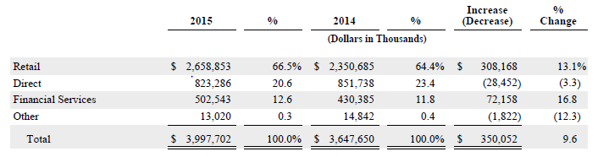
This table provides a comparative analysis of revenues earned by different business channels in 2014 and 2015. Retail sales pertain to revenue earned and recognized through purchases in retail locations. While direct sales pertain to revenue earned and recognized through catalog, phone, and internet orders that are shipped to a location of the customer’s choice. Financial services revenues are earned through the co-branded credit card. This includes interest earned on outstanding credit card balances. In the table, the revenue earning categories are listed from highest to lowest. (Cabela's 2015 Annual Report, 2015)

SWOT Analysis
Internal Environment
Cabela’s culture and their people. Cabela’s is passionate about the outdoors and the people who work and play there. Employees are pushed to work hard and achieve high standards; all the while being treated with respect and integrity. The nature of Cabela’s is the culture that has been created by having employees who love the outdoors as much as our customers do. (It's in Our Nature, n.d.) At Cabela’s they strive to share their knowledge and experiences of the outdoors with their customers. They want customers to know they can rely on the company for help with their camping or hunting needs. In an effort to create the desired nature here at Cabela’s, employees are treated as family, not as people passing through a job, but as a long-term member of a diverse family. In the Cabela’s family, employees are not scared of differences, they are instead, embraced and used to better serve customers.
Strengths. One of the strengths that Cabela’s has in its portfolio is its private label merchandise. In 2015, these goods comprised approximately 24% of merchandise revenue. (Cabela's 2015 Annual Report, 2015) The private label merchandise ranges from shoes, and jackets, to tents and archery equipment. The Cabela’s branded merchandise attracts customers because its high-quality merchandise that the retailer is able to offer at prices lower than large national brands. The multi-channel format of Cabela’s provides customers with a better experience. Not only can they shop in retail locations, but they can shop online and through catalogs. This format aides in Cabela’s ability to provide outstanding customer service. To provide an excellent experience to customers, customers can place orders online and have them available for in store pickup. In addition, retail locations have online kiosks and catalog order desks so that customers can easily order items they want that are not available in store.
Weaknesses. As with any growing company, Cabela’s unfortunately has some weaknesses. One such weakness is its reliance on foreign vendors. According to the 2015 Cabela’s financial report, 62% of branded merchandise was directly imported from vendors in foreign countries. (Cabela's 2015 Annual Report, 2015) It is also believed that some of their other vendors also import goods from foreign countries. This leaves Cabela’s in a vulnerable position. They are more susceptible to negative effects of exchange rate changes, political unrest in foreign countries, and government regulations. Revenue depends on a precariously high number of foreign vendors. Another weakness that Cabela’s has is the seasonality of its revenue. Due to the high number of sales occurring during open hunting season, Cabela’s sees a large portion of its earnings during the fourth quarter of every year. If earnings continue to decline during the strongest operating quarter the overall earnings will be impacted heavily. Unseasonably warm temperatures have also negatively impacted revenue during the fourth quarter. (Company Profile Cabela's Incorporated, 2016)
External Environment
Competition. Cabela’s competes with other specialty outdoor companies like Bass Pro Shops, Gander Mountain, and REI. They also compete with large sporting goods chains like Dick’s Sporting Goods, Big 5 Sporting Goods, and Academy Sports + Outdoors. In addition to sporting goods stores, Cabela’s is also in competition with retailers such as Wal-Mart and Target and online retailers like Amazon. (Masterson, 2016) According to The Market Share Reporter, “Leading sporting goods retailers”, Dick’s Sporting Goods has 9.46% of the market share while Bass Pro Shops has 5.90%, and Cabela’s has 4.77%. (Lazich & Burton, 2016)
Target market. According to IBISWorld Sporting goods industry report, the age group consisting of 18-44 years make up 42.5% of the industry revenue. The next largest age group is 45-64 years, with 31.9%. (Masterson, 2016) Cabela’s customers are outdoor enthusiasts who are specifically interested in hunting, fishing, and camping. In addition, customers are interested in outdoor apparel and footwear.
Opportunities. Cabela’s has seen opportunities present themselves in the market. The online retail market is expanding in the US. According to MarketLine, online retail sales increased from $169.8 billion in 2010 to $341.6 billion in 2015. (Company Profile Cabela's Incorporated, 2016) This translates into a huge opportunity for Cabela’s to gain business via their website. Another opportunity that Cabela’s has seen in the market is rising demands for private label goods. Consumers are increasingly looking for high quality private label merchandise at lower prices. This opportunity fits well with the already established Cabela’s brand.
Threats. Cabela’s is facing intense competition in the sporting goods industry. As was discussed earlier, they face competition from specialty outdoor retailers, concentrated sporting goods retailers, mass merchandise retailers. Some of these retailers could have better prices, larger product selection, more convenient locations, better websites, and so on. These companies might also have better financial reports recently. Another serious threat that Cabela’s is facing is the rising cost of labor in the US. Minimum wage rates have increased nationally to $7.25 per hour. Meanwhile, some states and cities have implemented higher rates, such as Santa Fe, New Mexico at $10 per hour and Alaska at $9.75 per hour. The increase in wage rates will increase Cabela’s operating expenses and in turn will lower profit levels.
Strategies and Implementation
In an effort to boost revenue amongst other things, management at Cabela’s is implementing several strategic plans. While each of these plans is going to be implemented separately within the company, they will all work together, fluidly, to increase profits and drive Cabela’s into the future retail market more successfully. It is important for Cabela’s to recognize that the consumers are spending more time and money shopping online. As a result, these strategies look to maximize their strengths as an online retailer and depend less on the struggling brick and mortar stores. The strategy is three-fold, first, the retail store expansion plans will be slowed, second, a new marketing campaign will be implemented, and lastly, the Cabela’s private label items will be carried in other retailers.
Expansion Plan
In recent years, consumer spending is increasingly being done on the internet. According to ICSC Research, “71% of adult Americans made purchases online in the past 30 days.” (A Closer Look at Online Spending, 2016) This supports the belief that focusing on Cabela’s.com is a necessity. The same study also indicates consumers are more likely to spend larger amounts with online retailers who also have a physical presence. Furthermore, consumers are utilizing offers of free shipping to be picked up in local physical stores. While the brick and mortar stores meet these needs, expansion plans need to be halted. It is unwise for Cabela’s to continue building new stores in the current market. According to an article in the Omaha World-Herald, “Sales at stores open at least one year fell 12% in 2014.” (Hubbard & Yowell, 2016)
Another negative trend that has been discovered in the continued expansion plan is cannibalization of existing stores sales. Cabela’s initial retail locations are referred to as legacy stores. These were opened in 2008 or earlier and range in size from 100,000 to 246,000 square feet. The legacy stores are commonly thought of as tourist attractions, instead of the local outdoor store. As of 2015, there are 28 of these legacy stores in the US and Canada. More recently Cabela’s has been opening smaller format stores, referred to as outpost stores, that range in size from 40,000 to 100,000 square feet. As of 2015, there were 49 of these stores across the US and Canada. (Cabela's 2015 Annual Report, 2015) In a Bloomberg article, it is noted that cannibalization amongst Cabela’s stores “looks severe”. (Stock, 2015) The smaller format stores are taking business from the legacy stores, which does not bode well for the future. In order to be successful, Cabela’s should be taking business from their competitors, not from their own stores.
According to the 2015 Annual Report, the drop in comparable stores sales can be attributed to a decrease in the number of transactions, by 12.2%, and 0.1% decrease in average sales per transaction. (Cabela's 2015 Annual Report, 2015) In light of this evidence Cabela’s will be halting any further expansion for at least one year’s time. Additionally, after this time period, if expansion is deemed attractive in a certain location, extensive market studies will be required before any construction can begin. New store expansion studies will ensure which markets can built in without taking any sales from the existing locations. During the time period in which expansion is halted, a portion of that spending will be allocated to a new marketing campaign.
Marketing
The new marketing campaign will be implemented through two strategies. The first will be the roll out of a new Cabela’s customer loyalty program. According to the Maritz Loyalty Marketing survey, members of rewards programs are more likely to have spent a greater amount of money in the past six months. (Loyalty-Program Members Spend More, 2006) Right now, only the Cabela’s Visa cardholders are given the opportunity to earn points to be used for future purchases. Cabela’s has decided it is time to give all of it’s customers access to a loyalty program that will be known as The Cabela’s Crew. This loyalty program will allow customers to earn points when purchases are made online, through the catalog, and in stores. As is customary with loyalty programs, the points can then be redeemed for merchandise. Customers will be able to apply for their Cabela’s Crew account online or in stores. When their Crew account is activated, an individual marketing relationship with the customer will begin.
The new loyalty program will be beneficial for Cabela’s not only in retention of customers, but also in the data gathering capacity. In order for them to gain more insight into what the customers want versus what they need, Cabela’s needs the ability to reach them and study their purchase behavior and even send purchase surveys. According to an article on Forbes.com, loyalty programs create a new product, data. In 2014, it is estimated The Kroger Co. sold $100 million in data to various suppliers. (Pearson, 2016) This presents an eye-opening opportunity for Cabela’s, not only can the marketing approach, the product offerings and the brand strength be refined through the new loyalty program, but a new revenue stream can be opened.
The Cabela’s Crew program will offer customers the opportunity to redeem points on merchandise purchases. Purchases of Cabela’s branded items will earn 2x points. Additionally, purchases of Cabela’s branded items will be eligible for free shipping. Customers will also have first choice opportunities at recreational classes offered in stores and in the local community. These classes will range from learning archery, canoeing, introduction to fishing, setting up a campsite, and many others. Customers will also be offered innovative discount opportunities. For instance, the refer a friend offer will implemented. Crew members and a friend will receive $10 to spend in their account when they refer a friend to the Crew and the friend makes their first purchase.
The second phase of the marketing strategy is to increase advertising presence in the local markets. Currently Cabela’s advertising is done through the website, traditional advertising, and some sponsorship events. They are going to increase radio and television ads in markets with and without local brick and mortar stores. According to a study published in Marketing Science, television remains the single most important advertising medium. (Wilbur, 2008) The focus of television advertising will be to increase ads run on local stations, as they are significantly less expensive than national ads. A local station can create a 30 second ad for $200 to $1500 as opposed to an ad produced by a professional national agency for $342,000. (Wagner, n.d.) The new ads will be run during news shows, as well as outdoor related shows.
Cabela’s is going to increase its presence in the radio advertising market as well as television. The interesting thing to note with radio listeners, is they mentally form a bond with the hosts of radio programs they listen to. David Field, president and CEO of Entercom Communications says, “recent studies confirm that more than half of radio listeners have considered or purchased a product or service advertised during their favorite radio personality’s show.” (Hanley, 2012) Cabela’s can capitalize on this bond by advertising during local radio shows in the same markets as their retail locations. Radio advertising costs will depend on the markets and timeslots that ads are run in. It is important to research each market and determine which time of day and days of the week that will most effectively reach the target market with radio ads.
Another new approach to local advertising is increasing the number of sponsored events in local communities. Cabela’s is going to get involved with school districts within the communities and sponsor events like archery in the schools. This will allow them to expose younger generations to the brand. They will partner with Parks and Recreation programs to offer introductory courses to outdoor activities. Cabela’s will also seek sponsorship opportunities with local children’s summer camps. Local brand exposure will help increase sales within retail stores and online. Cabela’s is committed to building its brand image and is going to take the necessary steps to build this image locally and then expand their reach nationally.
Cabela’s Private Label Changes
In an effort to capitalize on the strength of the Cabela’s brand, strategic changes are going to be implemented involving the private label items. According to the 2015 Annual Report, Cabela’s branded merchandise made up 24% of the merchandise revenue. In addition to this, the branded items generate higher gross profit margins. (Cabela's 2015 Annual Report, 2015) Cabela’s is going to diversify through related businesses. In an effort to capitalize on strong private label sales, they are going to seek strategic alliances with local businesses. According to an article in Franchising World, strategic alliances like these will allow Cabela’s to enter new markets without having to invest any additional time or money. (Buckles, 2011) Since expansion plans have been halted, Cabela’s will be able to expand into markets that currently do not have retail stores through these local alliances. They will seek to have their items carried in local hunting, archery, and outdoor stores. Cabela’s will partner with these local archery businesses to carry Cabela’s branded bows, arrows, targets and backpacks. Similarly, they will look to have hunting stores carry targets, blinds, backpacks, apparel, and even gun safes. Local outdoor stores will carry a combination of all Cabela’s items that fit the stores current product offerings.
Cabela’s established and respected brand name can help increase revenue for the local businesses that are partnered with. Through these local stores, Cabela’s will be able to increase revenues on their branded items. In addition to increased revenue, they look to gain more loyal Cabela’s customers while increasing revenues for local businesses. In utilizing this approach, they are looking to benefit both companies through leverage of Cabela’s branded products. It is important for Cabela’s and the local companies that form supply chain alliances to recognize these strategic alliances must be formed with complementarity, commitment, and compatibility in mind. According to an article in Academy of Management Perspectives, alliance success is more likely when firms are complementary to each other, are committed to the alliance, and have compatible business approaches. (Kale & Singh, 2009)
Reevaluation, Follow Up and Conclusion
Reevaluation and Follow Up
The strategies that Cabela’s implements need to be regularly monitored by management to determine their effectiveness. The number of new loyalty Crew memberships should be evaluated as well as items purchased for purchasing patterns. Monitoring these figures will allow Cabela’s to adjust product offerings and sales or coupon offers to boost sales in necessary segments. In addition, Cabela’s should regularly evaluate the revenue received from the sales of data gathered from the loyalty program. Changes to the expansion plans should be reevaluated on a yearly basis. Revenues in brick and mortar retail stores should be stable and rising before expansion resumes. Sales received from local stores should be closely monitored to determine the most effective product mix. Additionally, relationships with the local companies need to be of utmost importance to Cabela’s. They must strive to recognize any adaptations needed for both entities to continue with a successful alliance.
Conclusion
In an effort to remain The World’s Foremost Outfitter, Cabela’s has determined it is necessary to implement some changes within the company. They are going to change their marketing strategy, halt their expansion plans in the U.S., and form strategic alliances in order to have their private label items sold by local companies. In an everchanging business landscape it is imperative for Cabela’s to recognize when changes need to be made. If after evaluating company performance, weaknesses are found, the company should alter their operating strategies. With an open mind and willingness to modify business practices, Cabela’s should remain a big name in the recreation and outdoor sales industry for years to come.

References
(2016). A Closer Look at Online Spending. Industry Conditions ICSC.
Buckles, J. F. (2011, September). Understanding the Benefits and Challenges of Strategic Alliances. Franchising World, pp. 48-49.
Cabela's . (n.d.). Retrieved from Cabela's: http://www.cabelas.com/
(2015). Cabela's 2015 Annual Report. Sidney: Cabela's .
Cabela's Inc. (2006). Retrieved from Encyclopedia.com: http://www.encyclopedia.com/social-sciences-and-law/economics-business-and-labor/businesses-and-occupations/cabelas-inc
(2016). Company Profile Cabela's Incorporated. MarketLine.
Core Values. (n.d.). Retrieved from Cabela's Global Careers: http://cabelas.jobs/core-values/
Hanley, C. (2012, October 15). Radio Is... Adweek, p. R4.
Hauser, J. (2016, October 3). Timeline: History of Cabela's, 1961-2016. Retrieved from Scottsbluff Star Herald: http://www.starherald.com/townnews/commerce/timeline-history-of-cabela-s/article_f44530dc-1fd2-5c45-8dc1-38283323fd69.html
Hubbard, R., & Yowell, P. (2016, October 18). As Cabela's struggled to reap rewards of rapid growth, activist investor stepped in. Retrieved from Omaha World-Herald: http://www.omaha.com/money/as-cabela-s-struggled-to-reap-rewards-of-rapid-growth/article_c1076276-f61a-5493-b84e-83db368bccc0.html
It's in Our Nature. (n.d.). Retrieved from Cabela's Global Careers: http://cabelas.jobs/its-in-our-nature/
Kale, P., & Singh, H. (2009, August). Managing Strategic Alliances: What Do We Know Now, and Where Do We Go From Here? Academy of Management Perspectives, pp. 45-62.
Lazich, R. E., & Burton, V. L. (2016, August). Leading Sporting Goods Retailers 2015: Market Share Reporter. Retrieved from Gale Business Insights: Essentials: http://donnelly.nmhu.edu:2068/essentials/article/GALE%7CI2502058819/8fb3158ae8879fb95e8acd3c140ff8c2?u=nm_a_high
Loyalty-Program Members Spend More. (2006, September). Chain Store Age, p. 20.
Masterson, R. (2016). Sporting Goods Stores in the US. IBISWorld.
Our History - How We Became The World's Legendary Outfitter. (n.d.). Retrieved from Cabela's: http://www.cabelas.com/content.jsp?pageName=CompanyHistory
Pearson, B. (2016, January 4). 9 Things You Don't Know About Retail Loyalty Programs in 2016. Retrieved from Forbes.com: https://www.forbes.com/sites/bryanpearson/2016/01/04/9-things-you-dont-know-about-retail-loyalty-programs-in-2016/#3aed772c34df
Stock, K. (2015, October 22). Cabela's Massive Superstores are Cannabalizing Each Other. Retrieved from Bloomberg: https://www.bloomberg.com/news/articles/2015-10-22/cabela-s-massive-superstores-are-cannibalizing-each-other
Wagner, N. (n.d.). How Much Does Advertising Really Cost? Retrieved from Chron: http://smallbusiness.chron.com/much-television-advertising-really-cost-58718.html
Wilbur, K. C. (2008, May-June). A Two-Sided, Empirical Model of Television Advertising and Viewing Markets. Marketing Science, pp. 356-378.

