Tricia Graffeo, Logan Hanhardt, Dalaney Cummins

Sears holdings corp.

Table of contents
Executive Summary…………………………………………………………………………………………………………………………………..
Vision Statement……………………………………………………………………………………………………………………………………….
Mission Statement…………………………………………………………………………………………………………………………………….
SWOT…………………………………………………………………………………………………………………………………………………………
Strengths………………………………………………………………………………………………………………………………………
Well established national presence………………………………………………………………………………….
Own the rights to popular specialty brands………………………………………………………………………
Weaknesses………………………………………………………………………………………………………………………………….
Little to no online presence……………………………………………………………………………………………..
Bad websites….……………………………………………………………………………………………..
People have a bad image of Kmart…………………………………………………………………………………..
Kmart brand is perceived as low quality…………………………………………………………………………
Already in decline……………………………………..……………………………………………………………………
Opportunities…..………………………………………………………………………………………………………………………
Increase social media presence…………..………………………………………………………………
Improve websites and internet sales process…………………………………………………………………
Remodel and improve physical stores…..………………………………………………………………………
Revamp products….……………………………………………………………………………………………..
Publicize improvements…….…………………………………………………………………………………………
Better training for staff…..……………………………………………………………………………………………..
Specialize training for staff in specific areas…..…………………………………………………………………
Threats …………………………………………………………………………………………………………………………………..
E commerce giants (like amazon) own so much market share…..…………………………………
Other big box stores….……………………………………………………………………………………………..
Current Strategies………………………………………………………………………………………………………………………………
Currently closing down stores with low sales………………………………………………………………………………
Reducing outstanding debt and pension obligations…..………………………………………………………………
Generating cash through the sale of assets………………………
Financial statements……………………………………………………………………………………………………………………………….
Analysis…………………………………………………………………………………………………………………………………….
(Ad Graphs as necessary)
Recommendations/ Implementation….……………………………………………………………………………………………..
Hire a team to revamp websites and PR…..……………………………………………………………………..
And a team to help improve online advertising and social media presence..………………
Outsource the remodeling of stores……………………………………………………………………………
Top down employee training program…. ………………………………………………………………………………
Promoting innovation….……………………………………………………………………………………………..

Summary
We believe that by improving Sears Corp’s online presence, stores, staff, and products the corporation could see significant growth in both sales and market share.

Executive Summary

In order for a business to become and remain successful, they always need to evaluate their current and future strategies so that all strengths and weaknesses can be addressed. One tool that is extremely useful in doing is the SWOT (Strengths, Weaknesses, Opportunities and Threats) analysis. This can help a company identity what exactly is working for them or what is not working. It also helps them identify different opportunities that may be out there to assist them in changing what is not working for their company as well as help them prepare for any threats that they may incur. In this paper you will see that we have chosen a company that is experiencing financial difficulties and are on the verge of having to file for bankruptcy. We have notated some implementation ideas that we feel may help Sears Holding Co. improve their current financial situation as well as their long-term financial situation. If Sears Holding Co. could develop a successful business strategy they may be able to amend their current financial situation.

Vision Statement
Sears Holding is committed to improving the lives of our customers by providing quality services, product, and solutions that earn their trust and build lifetime relationships.

Mission Statement
To grow our business by providing quality products and services at great value when and where our customers want them. And by building positive and lasting relationships with our customers.

Strengths
Sears Holdings Corp was founded in 1886 as a catalog service and opened their retail stores in 1925. They had decades of success and grew into an international presence with stores across North America, Puerto Rico, and Guam. In 2005 Sears was bought out by Kmart Corporation. K Mart currently has 735 locations, and Sears has 695 in operation. The merged corporation already has a complete infrastructure and more than enough property. Their infrastructure is important because they do not need to go through the expense of expanding to new places, they simply need to invest in the property they already own.
Another strength that Sears can tap into is their ownership of a few specialty brands. This includes Kenmore, DieHard, etc. They can use these brands to expand on their image, to generate revenue, to attract new partners, and to create specialized services. Otherwise, the sale of these brands could potentially raise a large amount of cash and give them a boost to pay off debt. They recently sold Craftsmen for a large amount of cash, and a deal to continue carrying Craftsmen products without paying dues for a number of years. Assuming they can get more customers in their stores, this could prove to be a very good deal.

Weaknesses
In the current economy people are turning to the convenience of online shopping more and more. Which has proved problematic for many longstanding big box stores that ignored that demand. Sear’s Holdings Corp has a weak online presence and dysfunctional websites. Kmart.com and Sears.com both have bad web designs. The websites are not user friendly in their layout or function.
Many of the more successful online retailers also have a functional social media presence so they can easily interact with their customers. Sears Holdings has a slow response time to customer complaints via social media. If you look on Sears’ Facebook page it is filled with comments from dissatisfied customers. Their social media campaigns are uninteresting and don’t garner much attention.
Sears Holdings Corp. and K Mart Holdings Corp merged March 24, 2005, when K Mart was in the process of filing for Chapter 11 bankruptcy. K Mart has a bad brand image and is perceived as selling low quality products. Many of the Kmart buildings are older and need to be updated. Their stores tend to be disorganized and hard to navigate. Many of their stores are overstocked which makes their products difficult to look through. Kmart is known for selling low price products and many people associate that with lower quality.
As of quarter four of 2016 Sears Holdings Corp has been in steep decline for years. Since 2014 Sears has borrowed over 800 million dollars. Sears Holdings closed more than 200 stores in 2015, 78 stores in 2016, and are going to close at least 150 in the current year. This steep decline and increase in debt can be a huge weight on the corporation, and a looming problem for them as they try to make improvements. Also, because their financial problems are so public, each time a new article is written their brand image goes down even more.

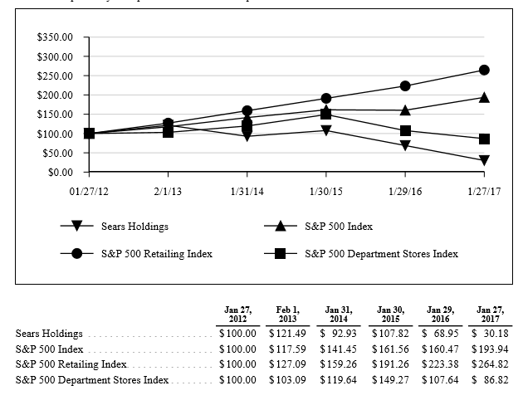

Opportunities
Sears Holdings has the assets and potential cash flow to take on major projects in order to improve their brand image and online presence. If they could improve their stores and products while offering a better online experience they would be back in competition with the other big-box stores. If they could offer their customers an easier, more convenient, online shopping experience they would increase customer loyalty and attracting new customers. They could find a new niche in the market by offering their staff specialized training in their respective fields, and therefor give customers better than expected customer services. And finally, by advertising and promoting these changes they could drastically improve their market share.

Threats
Sears Holdings, like many other retail stores, is experiencing decline in their market share at the e-commerce giants like Amazon. Only Sears was already in financial distress before the decline of their industry as a whole. Some retail giants recognized the threat of e-commerce early and have already expanded into it. Sears Holding Corp took longer than most, which puts them at a disadvantage. Both Sears and Kmart’s websites are badly designed and dysfunctional. Many of the common complaints on their social media profiles are about bad online experiences. They have not invested enough into this growing market segment that many customers are turning to.

Current Strategies
Sears is currently selling off assets to generate cash. In recent years they have sold multiple of their brands and some of their real estate holdings. They have generated 177.5 million from real estate sales as of April 2017, and have received bids in excess of 700 million on 60 other properties. They sold Craftsmen to black&decker for 900 million dollars cash net present value. They will receive 525 million at signing, another 250 million at the end of the third year and a percentage of annual sales for 15years. This generation of cash could be a very important step in decreasing their debt and opening the doors to new opportunities for the company.
Along with generating cash they are trimming their losses by closing less profitable locations. They have closed 150 stores in 2017, including 42 Sears stores and 108 Kmart’s. Plus 92 Kmart pharmacies and 50 Sears auto centers. The board of directors has developed a strategy to reduce expenses. Their targeted annualized cost savings is 1.25 billion dollars for the year. They plan to accomplish this by cutting costs anywhere possible.
They are trying to develop mega stores, for example their super K Mart in Michigan, Sears Grand stores, and standalone auto centers using their brand DieHard. This strategy seems to be a late reaction to the success of huge all-in-one stores like Walmart. Sears Corp decided to open Kmart stores containing banks, fast food restaurants, photo centers, and even dentist offices. At the same time they started adding things to Sears stores like a grocery section. This strategy doesn’t seem to be improving their current position, as they have already had to close some of these stores.

Financial Statements Analysis
Sears’ financial statements clearly show all the signs of distress they have been facing for years. They show mounting debt, negative retained earnings, and an operating loss. Sears Holdings has a debt to equity ratio of -3.45 because of their retained deficit. They also have a -.09 gross profit margin ratio that shows their struggle with costs. Their current ratio is a lackluster 1.07. This shows they could be managing their assets versus their debt much better. Overall Sears has many areas to improve in.
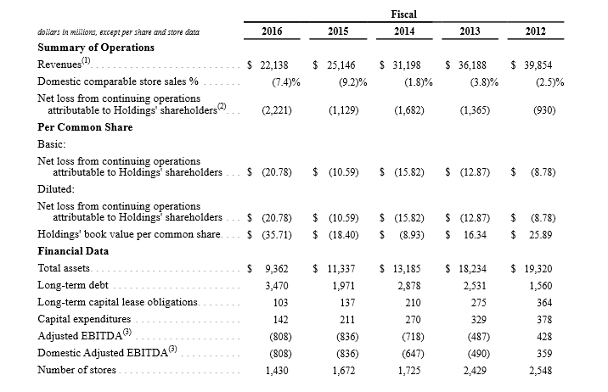

Recommendations/Implementation

Sears Corp needs to completely revamp their online strategy. In order to accomplish this they would need to hire a team of advertising experts and public relations personnel. The first step would be to redesign their website to increase functionality and improve appearance. After that they would need to start advertising on popular websites with high traffic. Following this they would need to create and execute a plan to better manage their social media accounts. This plan will include how to post fun and exciting content, how to respond to unsatisfied customers, and how to promote and define their brand image across all major social media platforms.
The next step in implementing our strategic plan is the physical remodeling of Sears and Kmart stores. Their multitudes of stores are a huge asset, but many of them are old and badly in need of repairs and updates. Although this will require a significant investment, we believe this is a necessary step in improving their brand image. The easiest way to do this would be to create a uniform design and layout for their stores worldwide. Having a consistent theme across different stores will make it easier and more enjoyable for people to shop in person. By contracting a third party for the remodeling they could get this done quickly and efficiently.
Keeping in mind that Kmart is branded as a more economical option, we believe it would be beneficial if they made a plan to improve product quality. If they put more effort into managing the brands they carry it is possible they could eliminate inferior products. They should have a plan to periodically perform product testing and look through customer reviews on the products they carry. They may be able to compensate for this expense in other departments. By raising their expectations for products they can show customers they have their best interest in mind.
Along with improving the quality of their stores and products, they should improve the quality of their employees by training their sales teams to be experts in their departments. Having a sales person with exceptional knowledge gives customers more confidence in their purchases. Which in turn will give customers a reason to return for future purchases. We believe this could be a unique opportunity for Sears to carve out their own niche in the industry. They have nation-wide stores and they carry a long list of tools and appliances. It would be a great convenience and value to customers if Sears was to offer project help, maintenance tips, tool selection advice, and expert opinions on the products they carry. This specialized service would help Sears and Kmart stores stand out from their competitors.
The final step of our strategic plan is for Sears to publicize these improvements, and make them known to both current and potential customers. One way of doing this would be to use their new and improved social media and online presence. Another option is to do grand reopening events and sales in all of their stores, so they can show off the changes they have made. If they can get people talking about the positive changes they will draw new people into stores and change their brand image in a real way. Once people are back in their stores hopefully they will be even more impressed with the improvements in customer service and product quality.

Summary

Sears is in serious financial trouble. In order to survive they will need to adapt quickly and find new strategies that show immediate results. Sears was once a leader in retail innovation, and they will need to find that niche in the market again. It may seem like Sears simply needs to follow the other retail giants and compete on that level. But we believe it will be more helpful for Sears to carve out their own unique segment in the market. With so many problems, Sears has many areas to start improving.

Resources

SEARS HOLDINGS CORPORATION Annual Reports. (n.d.). Retrieved from http://searsholdings.com/invest/annual-reports

Smith, M., & Orr, E. (2017, February 10). Sears Rallies After CEO Assures Investors He Has Comeback Plan. Retrieved March 3, 2017, from https://www.bloomberg.com/news/articles/2017-02-10/sears-soars-on-plan-to-cut-debt-pension-burden-by-1-5-billion

Sears Holdings Corporation (SHLD). (n.d.). Retrieved from https://finance.yahoo.com/quote/SHLD?ltr=1
Jones, C. (2017, March 21). Sears and Kmart might not have enough money to stock their shelves. Retrieved March 7, 2017, from https://www.usatoday.com/story/money/business/2017/03/21/sears-says-substantial-doubt-can-stay-business/99479726/

Stewart, J. B. (2017, March 30). Sears and Its Hedge Fund Owner, in Slow Decline Together. Retrieved from https://www.nytimes.com/2017/03/30/business/edward-lampert-sears-kmart.html?%20r=0&_r=0

